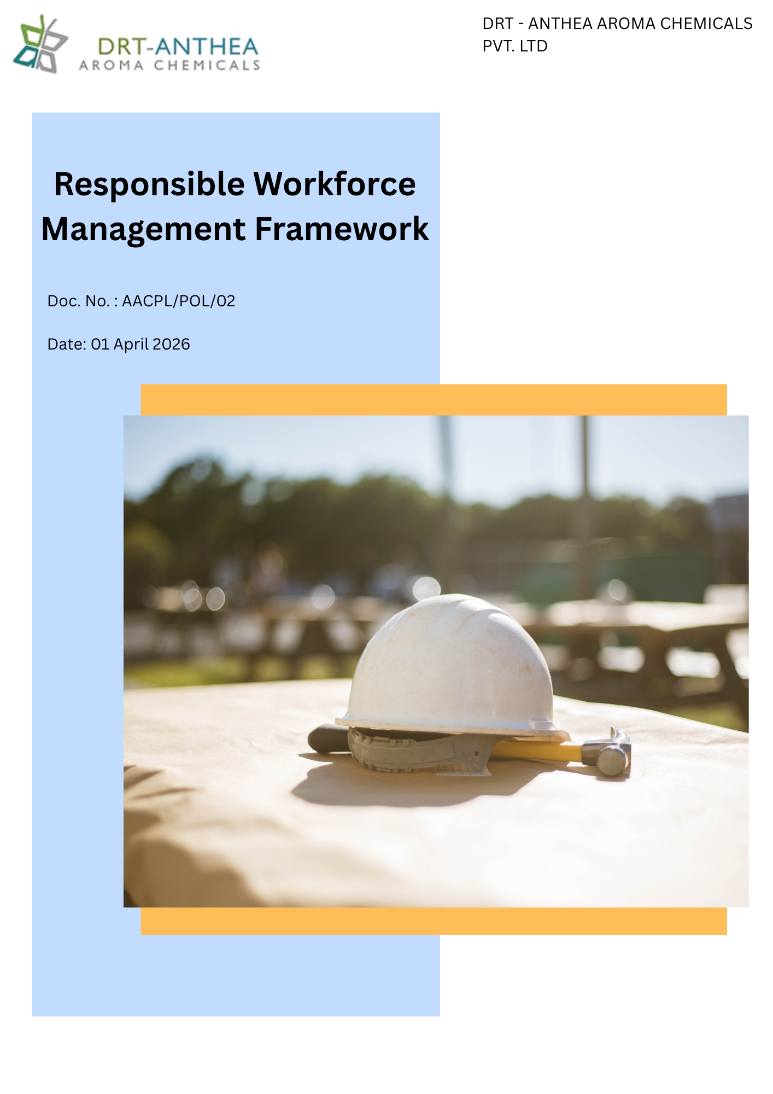

Table of Contents
List of Abbreviations: 3
1. Alignment with Anthea Group Responsible Workforce Management Framework 4
2. Preamble 4
3. Objective 5
4. Scope 5
5. Key Performance Areas 6
5.1 Occupational Health and Safety 6
5.2 Discrimination and Harassment 6
5.3 Workplace Practices 6
5.4 Skill & Career Management and Training 6
5.5 Child Labor, Forced Labor, and Human Trafficking 7
5.6 Social Dialogue 7
5.7 Employee Wellbeing and Welfare 7
5.8 Grievance Mechanism and Ethical Workplace 7
6. Commitments & Targets 7
6.1 Employee Health and Safety 8
6.2 Discrimination and Harassment 9
6.3 Working Conditions 10
6.4 Career Management and Training 11
6.5 Child Labor, Forced Labor, and Human Trafficking 12
6.6 Social Dialogue 13
6.7 Employee Wellbeing and Welfare 13
6.8 Grievance Mechanism and Ethical Workplace 14
7. Governance and Responsibilities 15
8. Reporting 16
9. Policy Alignment with SDGs 17
10. Review Mechanism 17
11. Employee Acknowledgement Form 18

List of Abbreviations:

Abbreviation | Full Form
ESG | Environmental, Social and Governance
EHS | Environment, Health & Safety
HR | Human Resources
H&S | Health and Safety
HRMS | Human Resource Management System
FY | Financial Year
KPI | Key Performance Indicator
LTIFR | Lost Time Injury Frequency Rate
CAPA | Corrective and Preventive Action
PPE | Personal Protective Equipment
IDP | Individual Development Plan
SDGs | Sustainable Development Goals
MIDC | Maharashtra Industrial Development Corporation

Alignment with Anthea Group Responsible Workforce Management Framework
To support and align with the people-centric vision, workforce commitments, and strategic objectives of the Anthea Group, DRT-Anthea Aroma Chemicals Pvt. Ltd. has established this Responsible Workforce Management Framework as a comprehensive approach for managing its workforce responsibilities across all business operations. The Framework is designed to foster a safe, inclusive, respectful, and engaging workplace while promoting employee well-being, fair labour practices, diversity, equal opportunity, capability development, and compliance with applicable labour laws and international standards.
To facilitate the effective implementation of this Framework, the Company has also developed an internal Responsible Workforce Management Roadmap, which translates the Group's workforce priorities into site-specific objectives, targets, action plans, and performance monitoring mechanisms. This Roadmap supports the continuous enhancement of workforce management practices, employee engagement, occupational health and safety, talent development, and organizational culture, while reinforcing the Company's commitment to responsible and sustainable business operations.

Preamble
DRT – Anthea Aroma Chemicals Pvt. Ltd. is committed to fostering a workplace where human rights are respected, employees are treated with dignity and fairness, and everyone has the opportunity to work in a safe, inclusive, and supportive environment. As a manufacturer of specialty aroma chemicals, the Company recognizes that protecting labor and human rights is fundamental to sustainable business growth, operational excellence, regulatory compliance, and long-term value creation for employees, customers, business partners, and other stakeholders.
This Responsible Workforce Management Framework establishes the Company's commitment to upholding internationally recognized human rights principles and complying with all applicable labor laws and regulations across its manufacturing facilities located at Unit I and Unit II in Roha, Raigad, Maharashtra. The policy provides a comprehensive framework for promoting occupational health and safety, preventing discrimination and harassment, ensuring fair working conditions, supporting employee learning and career development, prohibiting child labor, forced labor, and human trafficking, and fostering open social dialogue and employee engagement. Through this policy, DRT–Anthea Aroma Chemicals Pvt. Ltd. aims to cultivate a respectful, ethical, and responsible workplace culture while driving continual improvement in labor and human rights performance across its operations and business relationships.

Objective
The objective of this Responsible Workforce Management Frameworkis to establish a comprehensive framework for promoting and protecting labor and human rights across the operations of DRT – Anthea Aroma Chemicals Pvt. Ltd. and to foster a safe, inclusive, ethical, and respectful workplace for all employees and workers associated with the Company.
This policy aims to:
- Ensure compliance with all applicable labor laws, employment regulations, human rights principles, and other statutory requirements.
- Protect the health, safety, and wellbeing of employees by maintaining a safe and healthy working environment and preventing occupational injuries and illnesses.
- Promote equal employment opportunities and maintain a workplace free from discrimination, harassment, bullying, retaliation, and any form of unfair treatment.
- Provide fair and lawful working conditions, including equitable wages, working hours, employee benefits, leave entitlements, welfare facilities, and respectful treatment in accordance with applicable legal requirements.
- Support employee growth through continuous learning, competency development, performance management, and equal access to career development opportunities.
- Prohibit all forms of child labor, forced labor, bonded labor, compulsory labor, human trafficking, and any other form of modern slavery throughout the Company's operations and, where applicable, within its supply chain.
- Respect employees' rights to freedom of association, collective bargaining where legally applicable, and constructive social dialogue while encouraging open communication and employee participation.
- Provide accessible, confidential, and transparent grievance mechanisms that enable employees to raise concerns without fear of retaliation and ensure timely investigation and resolution.

Scope
This Responsible Workforce Management Frameworkapplies to all business activities and employment practices of DRT–Anthea Aroma Chemicals Pvt. Ltd. The policy is applicable to all permanent employees, temporary employees, contract workers, trainees, apprentices, interns, consultants, and other personnel working on behalf of the Company. The Company also expects contractors, suppliers, service providers, and business partners to uphold the principles set forth in this policy and to conduct their operations in a manner consistent with applicable labor laws, human rights standards, and ethical business practices.

The scope of this policy covers all operational locations of the Company, including:
- Unit I: Plot Nos. 49, 50 & 51 A, MIDC Dhatav, Roha, Dist. Raigad – 402116, Maharashtra, India.
- Unit II: Plot No. 51 A/1, Roha Industrial Area, Village Roth Budruk, Roha, Dist. Raigad – 402116, Maharashtra, India.
This policy encompasses all employment-related activities, including recruitment and hiring, onboarding, working conditions, occupational health and safety, wages and benefits, working hours, employee welfare, performance management, learning and development, career advancement, equal opportunity, diversity and inclusion, prevention of discrimination and harassment, grievance management, social dialogue, and the prevention of child labor, forced labor, bonded labor, human trafficking, and other forms of modern slavery across the Company's operations and, where applicable, within its supply chain.

Key Performance Areas

5.1 Occupational Health and Safety
Promote a safe, healthy, and secure working environment by preventing occupational injuries and illnesses, identifying and mitigating workplace hazards, ensuring emergency preparedness, and fostering a proactive safety culture through employee participation, training, and continual improvement.

5.2 Discrimination and Harassment
Maintain a workplace that is free from discrimination, harassment, bullying, retaliation, and any form of inappropriate behavior by promoting equal opportunity, diversity, inclusion, dignity, respect, and fair treatment for all employees.

5.3 Workplace Practices
Provide fair, safe, and lawful working conditions by ensuring compliance with applicable labor laws relating to working hours, wages, benefits, leave, welfare facilities, employment practices, and workplace wellbeing while promoting work-life balance.

5.4 Skill & Career Management and Training
Support employee growth and long-term career development through fair performance management, competency development, equal access to learning opportunities, leadership development, succession planning, and continuous professional training.

5.5 Child Labor, Forced Labor, and Human Trafficking
Maintain zero tolerance for child labor, forced labor, bonded labor, compulsory labor, prison labor, debt bondage, human trafficking, and any other form of modern slavery throughout the Company's operations and, where applicable, its supply chain.

5.6 Social Dialogue
Promote open, transparent, and constructive communication between management and employees by respecting freedom of association, enabling employee participation, encouraging consultation, supporting grievance mechanisms, and maintaining positive industrial relations.

5.7 Employee Wellbeing and Welfare
Promote the physical, mental, and social wellbeing of employees by providing appropriate welfare facilities, supporting work-life balance, encouraging wellness initiatives, and fostering a healthy, respectful, and engaging work environment that enhances employee satisfaction and productivity.

5.8 Grievance Mechanism and Ethical Workplace
Maintain accessible, confidential, and transparent grievance mechanisms that enable employees and workers to raise concerns without fear of retaliation. Promote ethical conduct, accountability, fair investigation of complaints, and timely resolution of workplace issues while strengthening trust and integrity across the organization.

Commitments & Targets
Baseline Year: FY 2023-24
DRT – Anthea Aroma Chemicals Pvt. Ltd. is committed to fostering a safe, inclusive, ethical, and respectful workplace by integrating labor and human rights principles into its business operations and employment practices. The Company shall pursue the following commitments and qualitative targets to strengthen employee wellbeing, uphold internationally recognized human rights, ensure compliance with applicable labor laws, and promote continual improvement across its operations and value chain.

6.1 Employee Health and Safety
Objective | Commitment | Target (Baseline Year: FY 2023-24) | Future Action Plan
Occupational Health & Safety | Provide and maintain a safe and healthy workplace for all employees, contractors, and visitors. | Maintain Zero Fatalities and reduce the Lost Time Injury Frequency Rate (LTIFR) through continual improvement by FY 2029-30. | Hazard identification and risk assessments, implementation of safety controls, routine workplace inspections, and preventive actions.
Legal Compliance | Ensure compliance with applicable occupational health and safety laws, regulations, permits, and internal requirements. | Maintain 100% compliance with applicable occupational health and safety legal and regulatory requirements annually. | Periodic legal compliance evaluations, internal audits, corrective and preventive actions (CAPA), and management reviews.
Safety Training & Awareness | Strengthen employee competency and promote a proactive safety culture across all operations. | Provide annual occupational health and safety training to 100% of employees, trainees, and relevant contractors. | Employee induction, refresher training, toolbox talks, emergency response drills, and safety awareness campaigns.
Incident Prevention & Reporting | Prevent workplace incidents through timely reporting, investigation, and implementation of corrective actions. | Investigate 100% of reportable incidents and near misses and implement corrective actions within defined timelines. | Incident reporting system, root cause analysis, CAPA implementation, trend analysis, and periodic management review.
Emergency Preparedness | Enhance preparedness for workplace emergencies to protect employees, assets, and the environment. | Conduct at least two emergency preparedness and response drills annually at each manufacturing facility. | Emergency response plans, mock drills, evacuation exercises, first-aid preparedness, and periodic review of emergency procedures.
Occupational Health & Wellbeing | Protect employee health by identifying and managing occupational health risks arising from workplace activities. | Conduct 100% periodic occupational health assessments for employees exposed to identified occupational hazards, in accordance with applicable legal and operational requirements. | Periodic medical examinations, workplace exposure monitoring, industrial hygiene assessments, health surveillance, and employee wellness initiatives.

6.2 Discrimination and Harassment
Objective | Commitment | Target (Baseline Year: FY 2023-24) | Future Action Plan
Equal Opportunity | Promote a workplace that provides equal employment opportunities and fair treatment to all employees regardless of gender, age, race, religion, caste, nationality, disability, marital status, or any other legally protected characteristic. | Maintain 100% compliance with the Company's Equal Employment Opportunity principles and applicable anti-discrimination laws annually. | Fair recruitment and promotion practices, objective performance evaluations, periodic policy reviews, and awareness programs.
Prevention of Discrimination & Harassment | Maintain a workplace free from discrimination, harassment, bullying, retaliation, and any form of inappropriate workplace behavior. | Achieve Zero Tolerance for substantiated cases of discrimination, harassment, or workplace bullying through timely investigation and corrective actions. | Implementation of anti-discrimination and anti-harassment policies, confidential reporting channels, prompt investigations, and disciplinary actions where appropriate.
Employee Awareness & Training | Build employee awareness and promote a culture of dignity, inclusion, and mutual respect. | Provide annual discrimination and harassment prevention training to 100% of employees, supervisors, managers, and relevant contractors. | Employee induction, refresher training, awareness campaigns, leadership workshops, and behavioral competency programs.
Grievance Handling | Ensure employees can raise concerns without fear of retaliation through accessible and confidential reporting mechanisms. | Investigate and address 100% of reported discrimination and harassment complaints within established timelines. | Confidential grievance mechanisms, impartial investigations, corrective and preventive actions (CAPA), and periodic monitoring of complaint resolution.
Workplace Culture Monitoring | Continuously evaluate workplace culture to identify improvement opportunities related to respect, inclusion, and employee experience. | Conduct an employee workplace culture or satisfaction survey at least once every two years and implement improvement actions where applicable. | Employee feedback surveys, management reviews, action plans, awareness initiatives, and monitoring of organizational culture indicators.

6.3 Working Conditions
Objective | Commitment | Target (Baseline Year: FY 2023-24) | Future Action Plan
Fair Employment Practices | Provide fair, lawful, and equitable employment conditions for all employees. | Maintain 100% compliance with applicable labor laws relating to wages, working hours, leave, and statutory benefits annually. | Periodic legal compliance reviews, payroll verification, internal audits, and policy updates.
Employee Welfare Facilities | Provide safe, hygienic, and adequate welfare facilities that support employee wellbeing and productivity. | Maintain 100% availability and periodic inspection of applicable employee welfare facilities annually. | Maintenance of canteen, sanitation, drinking water, rest areas, PPE, and welfare inspections.
Fair Compensation & Benefits | Ensure employees receive fair wages, statutory benefits, and timely remuneration. | Ensure 100% timely payment of wages and statutory benefits in accordance with applicable legal requirements. | Payroll management, statutory compliance monitoring, benefit administration, and internal verification.
Workplace Risk Assessment | Identify and address workplace risks that may impact employee wellbeing and working conditions. | Conduct workplace condition assessments at all manufacturing facilities at least once every year. | Workplace inspections, employee feedback, corrective actions, and periodic reviews.
Employee Awareness | Promote awareness of employee rights, responsibilities, and workplace standards. | Provide annual awareness training on employee rights, workplace conduct, and Company policies to 100% of employees. | Employee induction, refresher training, policy communication, and awareness campaigns.

6.4 Career Management and Training
Objective | Commitment | Target (Baseline Year: FY 2023-24) | Future Action Plan
Learning & Development | Promote continuous learning and competency development for employees. | Provide at least one structured training program annually to 100% of employees, based on role and business requirements. | Annual training calendar, competency mapping, technical and behavioral training.
Performance Management | Ensure fair and transparent performance evaluation processes. | Conduct 100% annual performance evaluations for eligible employees. | Performance appraisal system, objective setting, feedback discussions, and development planning.
Career Development | Support employee career growth through equal access to development opportunities. | Prepare Individual Development Plans (IDPs) for 100% of eligible employees where applicable. | Career discussions, competency assessment, mentoring, and succession planning.
Leadership Development | Build future organizational capability through leadership development initiatives. | Conduct at least one leadership development program annually for identified employees. | Leadership workshops, coaching, mentoring, and cross-functional exposure.
Skills Assessment | Continuously evaluate employee competencies to meet operational requirements. | Conduct annual competency assessments for employees performing critical functions. | Skills matrix review, competency evaluations, refresher training, and qualification tracking.
Employee Awareness | Promote a culture of continuous improvement and lifelong learning. | Achieve 100% employee participation in mandatory compliance and competency training annually. | Learning Management System (where applicable), awareness campaigns, and training effectiveness evaluations.

6.5 Child Labor, Forced Labor, and Human Trafficking
Objective | Commitment | Target (Baseline Year: FY 2023-24) | Future Action Plan
Prevention of Child Labor | Prohibit the employment of child labor across all Company operations. | Maintain Zero Child Labor across all operations annually. | Age verification procedures, recruitment controls, document verification, and periodic audits.
Prevention of Forced Labor | Eliminate all forms of forced, bonded, compulsory, or involuntary labor. | Maintain Zero Incidents of Forced or Bonded Labor annually. | Ethical recruitment practices, voluntary employment verification, and employee interviews.
Prevention of Human Trafficking | Prevent human trafficking and all forms of modern slavery within Company operations. | Maintain Zero Cases of Human Trafficking or Modern Slavery annually. | Supplier due diligence, awareness programs, contractual requirements, and compliance monitoring.
Supplier Compliance | Promote responsible labor practices throughout the supply chain. | Communicate labor and human rights expectations to 100% of strategic suppliers by FY 2029-30. | Supplier Code of Conduct, supplier assessments, audits, and corrective action plans.
Employee Awareness | Increase awareness regarding modern slavery and ethical employment practices. | Provide annual awareness training to 100% of HR personnel, managers, and relevant employees. | Training programs, induction sessions, awareness campaigns, and policy communication.
Monitoring & Compliance | Strengthen monitoring of labor and human rights compliance across operations. | Conduct annual labor and human rights risk assessments and internal audit at manufacturing facilities. | Internal audits, legal compliance reviews, management reviews, and corrective actions.

6.6 Social Dialogue
Objective | Commitment | Target (Baseline Year: FY 2023-24) | Future Action Plan
Employee Communication | Promote open, transparent, and respectful communication between employees and management. | Conduct at least two employee communication sessions annually at each manufacturing facility. | Town hall meetings, departmental meetings, suggestion schemes, and employee engagement activities.
Freedom of Association | Respect employees' rights to freedom of association and collective dialogue in accordance with applicable laws. | Maintain 100% compliance with applicable legal requirements relating to employee representation and collective bargaining agreement annually. | Policy implementation, management engagement, and legal compliance monitoring.
Employee Participation | Encourage employees to actively participate in workplace improvement initiatives. | Implement at least one employee engagement initiative annually in each department. | Suggestion schemes, quality circles, safety committees, and improvement programs.
Communication Effectiveness | Improve employee awareness of Company policies and organizational changes. | Achieve 100% communication of significant policy updates to all relevant employees. | Circulars, toolbox talks, digital communication, notice boards, and awareness sessions.
Continuous Improvement | Strengthen employee engagement and organizational trust. | Conduct employee engagement surveys at least once every two years and implement improvement actions where applicable. | Employee surveys, management review, action plans, and performance monitoring.

6.7 Employee Wellbeing and Welfare
Objective | Commitment | Target (Baseline Year: FY 2023-24) | Future Action Plan
Employee Wellbeing | Promote the physical and mental wellbeing of employees. | Conduct at least one employee wellbeing initiative annually at each manufacturing facility. | Health awareness campaigns, wellness programs, stress management sessions, and fitness initiatives.
Occupational Health | Support employee health through preventive healthcare initiatives. | Conduct periodic health check-ups for 100% of eligible employees in accordance with applicable legal and operational requirements. | Medical examinations, health monitoring, vaccination programs, and occupational health surveillance.
Employee Welfare | Maintain adequate welfare facilities that enhance employee comfort and wellbeing. | Maintain 100% operational availability of applicable welfare facilities annually. | Maintenance of canteen, sanitation, drinking water, rest rooms, transportation, and housekeeping.
Work-Life Balance | Encourage a healthy balance between work responsibilities and personal wellbeing. | Review employee wellbeing indicators annually and implement improvement initiatives where applicable. | Leave management, flexible planning where feasible, employee assistance initiatives, and wellness awareness.
Health care plan | Provide adequate health care plan to employee | Cover 100% of the employees in health care plan | Health insurance policy
Continuous Improvement | Enhance employee wellbeing through periodic assessment and review. | Conduct annual reviews of employee wellbeing and welfare programs and implement improvement actions where required. | Employee feedback surveys, KPI monitoring, management review, and continual improvement initiatives.

6.8 Grievance Mechanism and Ethical Workplace
Objective | Commitment | Target (Baseline Year: FY 2023-24) | Future Action Plan
Grievance Mechanism | Provide accessible, confidential, and transparent grievance channels for all employees. | Investigate and respond to 100% of reported grievances within established timelines. | Grievance procedure, confidential reporting channels, investigation process, and corrective actions.
Protection Against Retaliation | Ensure employees can raise concerns without fear of retaliation or unfair treatment. | Maintain Zero Tolerance for retaliation against employees raising concerns in good faith. | Non-retaliation policy, management oversight, confidential investigations, and awareness programs.

Governance and Responsibilities
Effective implementation of this Responsible Workforce Management Framework requires active leadership, accountability, and participation across all levels of DRT–Anthea Aroma Chemicals Pvt. Ltd. The following governance structure defines the roles and responsibilities for ensuring compliance with labor laws, protecting human rights, promoting employee wellbeing, and achieving the Company's labor and human rights commitments.
Role | Key Responsibilities
Executive Management | • Provide strategic direction and leadership for labor and human rights management.  • Approve the Responsible Workforce Management Framework and related objectives.  • Allocate adequate financial, technological, and human resources for policy implementation.  • Review labor and human rights performance and ensure continual improvement through Management Review meetings.
Plant Head | • Ensure effective implementation of the Responsible Workforce Management Framework across Unit I and Unit II.  • Ensure compliance with applicable labor laws, human rights requirements, and Company policies.  • Monitor achievement of labor and human rights objectives, targets, and KPIs.  • Foster a safe, inclusive, respectful, and ethical workplace culture.
Human Resources (HR) Department | • Develop, implement, and maintain labor and human rights management practices.  • Ensure fair recruitment, employment, compensation, performance management, and employee welfare practices.  • Coordinate employee induction, competency development, awareness, and training programs.  • Manage grievance mechanisms, employee engagement initiatives, and workplace investigations where applicable.  • Monitor compliance with labor laws and maintain employee-related records.
Environment, Health & Safety (EHS) Department | • Promote occupational health and safety across all operations.  • Conduct workplace risk assessments, safety inspections, and emergency preparedness activities.  • Monitor occupational health and safety performance and recommend corrective actions.  • Conduct health and safety awareness programs and support employee wellbeing initiatives.
Supervisors & Line Managers | • Ensure employees work in accordance with Company policies, procedures, and applicable labor requirements.  • Promote a workplace free from discrimination, harassment, and retaliation.  • Encourage open communication, promptly address employee concerns, and report workplace issues.  • Support employee development, performance feedback, and wellbeing initiatives.
Employees & Contract Workers | • Comply with this Responsible Workforce Management Framework and all applicable Company procedures.  • Treat colleagues with dignity, respect, and professionalism.  • Report unsafe conditions, discrimination, harassment, unethical conduct, or labor and human rights concerns through appropriate reporting channels.  • Participate in mandatory training programs and contribute to maintaining a safe, inclusive, and respectful workplace.

Reporting
DRT – Anthea Aroma Chemicals Pvt. Ltd. shall establish and maintain a systematic process for monitoring, recording, and reporting its labor and human rights performance across Unit I and Unit II. Reporting shall include key performance indicators such as occupational health and safety performance, employee training and competency development, working conditions, employee wellbeing, discrimination and harassment cases, grievances, employee engagement, compliance with applicable labor laws, and the prevention of child labor, forced labor, and human trafficking.
The Human Resources (HR) Department, in coordination with the Environment, Health & Safety (EHS) Department and other relevant functions, shall periodically review labor and human rights performance and report progress against the Company's objectives, commitments, and targets to the Management. Relevant records shall be maintained to demonstrate legal compliance, support customer and stakeholder requirements, facilitate internal audits and management reviews, and drive the continual improvement of the Company's labor and human rights management practices.

Policy Alignment with SDGs

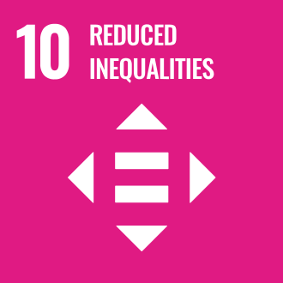
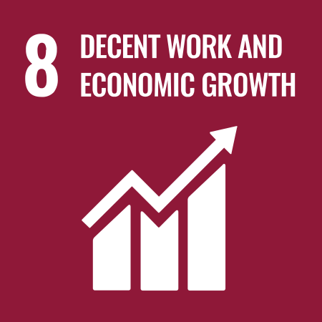




Review Mechanism
This Responsible Workforce Management Framework shall be reviewed at least once every year, or earlier if required due to changes in applicable labor laws, human rights standards, regulatory requirements, business operations, organizational structure, stakeholder expectations, or emerging labor and human rights risks. The review shall ensure that the policy remains relevant, effective, and aligned with the Company's strategic objectives, sustainability commitments, and internationally recognized labor and human rights principles.
The review shall be coordinated by the Human Resources (HR) Department in consultation with the Environment, Health & Safety (EHS) Department and approved by the Management. Any revisions arising from the review shall be communicated to all relevant employees and stakeholders, and appropriate actions shall be implemented to support the continual improvement of the Company's labor and human rights management practices.

Authorized by:

Legal & Compliance Head
DRT – Anthea Aroma Chemicals Pvt. Ltd.

Employee Acknowledgement Form
I acknowledge that I have read, understood, and agree to comply with the Responsible Workforce Management Frameworkof DRT–Anthea Aroma Chemicals Pvt. Ltd. I understand my responsibility to uphold the principles of respect, equality, fairness, workplace safety, ethical conduct, and human rights by complying with applicable Company policies, labor laws, and established procedures, and by contributing to a safe, inclusive, and respectful workplace.
I further acknowledge that compliance with this policy is a condition of my employment and that I am committed to supporting the Company's labor and human rights objectives, reporting any concerns or violations through appropriate channels, participating in mandatory training and awareness programs, and contributing to the continual improvement of the Company's labor and human rights performance.
Employee Name: _______________________________________
Employee ID: _________________________________________
Department: __________________________________________
Designation: _________________________________________
Signature: ___________________________________________
Date: ________________________________________________

